Young Adult ICCC Conference Schedule – Cherry Hill, NJ

Monday, July 17
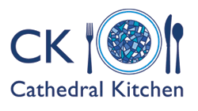
10:00a – Worship
3:30p-5:30p – Cathedral Kitchen
1514 Federal Street
Camden, NJ 08105
7:00p – Higher Grounds Coffee and Refreshments Hour 8:15p – Movie: To Save a Life

Tuesday, July 18
10:00a – Bible Study
12:30p-4:00p – Philabundance
3616 South Galloway Street Philadelphia, PA 19148
7:00p – Worship 8:15p – Entertainment

Wednesday, July 19
10:00a – Bible Study
12:30p-2:30p – New Visions Homeless Day Shelter
555B Atlantic Avenue Camden, NJ
6:00p-7:00p – Sunday Breakfast Rescue Mission 302 N. 13th Street
Philadelphia, PA 19107 7:00p – Worship

Thursday, July 20
11:00a – Worship
1:00p – Philadelphia Sightseeing 6:30p – Annual Conference Banquet

